**Risk Assessment for Nottingham Digit Monitoring Equipment**

Note: RA and SOP currently only for prototype and protocol testing phase

1. **Laboratories**:

7T Magnet Hall and MEG scan room, both in the Sir Peter Mansfield Imaging Centre (SPMIC) (University Park)

2. **Brief Description of Work Activity:**

The Nottingham Digit Monitor equipment (DM) provides the facility to monitor the positions of the digits on one hand during a functional MRI or MEG study. During a functional paradigm, a subject freely (on visual cue for example) taps or exercises one or more digits. Miniature accelerometers attached to the fingertips record the accelerations. The device is purely passive in that it only records activity for later analysis.

3. **List of Main Hazards:**

* Projectile hazard (MRI only): Interface Unit and connectors contain some ferrous components.
* RF heating (MRI only): Cables are connected to in-bore equipment and sensors are taped to subject. There is no direct electrical contact to subject.

4. **Hazard rating (1-4)**: 2

5. **List of Control Measures currently in place:**

For reference a system diagram is shown here:

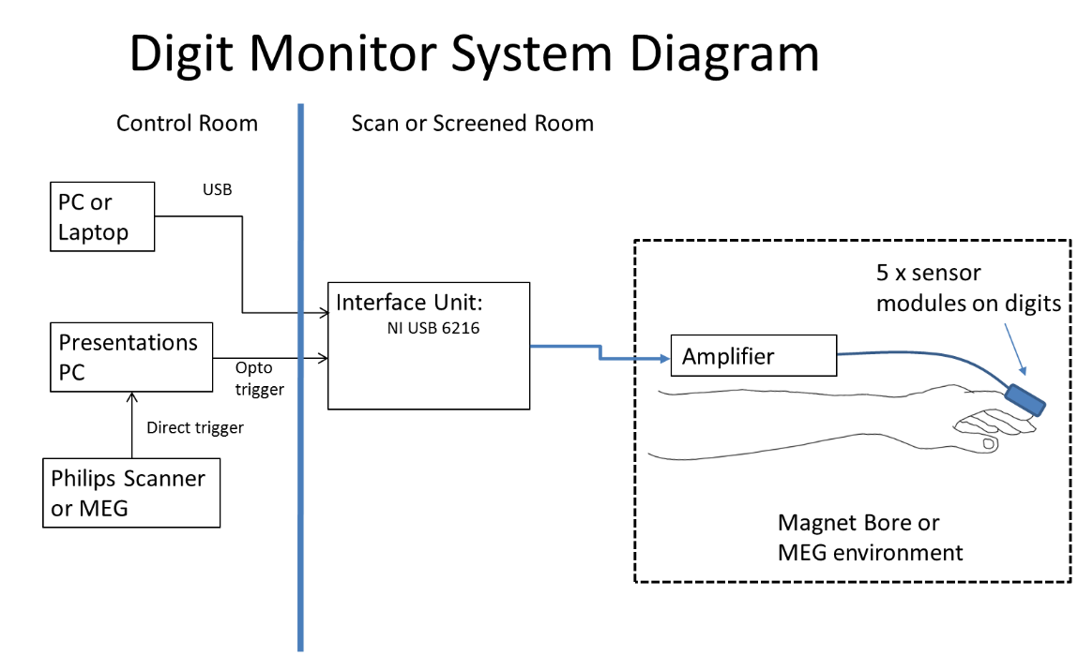

* The DM is specifically designed to be MRI and MEG Compatible. The Amplifier Head Stage is designed for intra-bore use at 7T. The Interface unit with connectors, whilst not a significant projectile risk, is not designed to work in high magnetic fields and should be placed at the designated location (right next to waveguide port near door).
* Plugs on the cables should be considered as magnetic and constitute a projectile hazard. They should be connected to the Interface box before laying out the cables.
* Only competent SPMIC staff can take (or give approval for taking) equipment or other required items into the scan room (e.g. swabs, electrodes, electrode leads, pads, blankets or cushions).
* For MRI, the lead to the Amplifier Head-Stage (strapped to lower arm) must be arranged axially along (but not touching) the subject’s legs and body to the end of the bed. A foam tube is used to ensure >2cm separation from cable to body.
* There are no additional or significant hazards using this equipment in the MEG room. There are no SAR/heating or cable routing constraints.
* Device Isolation is currently provided (for prototype testing) through the galvanic isolation intrinsic to the USB interface. Optical fibre isolation is provided for synchronisation signal. No part of the isolated side of the DM system should be connected to any other equipment or to ground. For prototype testing the laptop should be powered by battery only.
* RF and SAR testing has not been carried out fully yet (prototype testing shows no apparent heating effects).
* Only MR sequences tested and approved can be used with this equipment (see SOP).
* Only pre-agreed programmed pulse protocols should be used.
* Only named persons (see SOP) can set up and/or use this equipment in the 7T and must read and sign this risk assessment.

6. **Risk Factor (1-4):** 1

7. **If Hazard x Risk > 4 List other measures needed to reduce risk to acceptable levels:** N/A.

8. **Signed:**

Assessor Dr Paul Glover Date:

9. **Review Schedule:**

Issue date: Jan 2018

Revised:

Standard Operating Procedure for Nottingham Digit Monitor equipment in 7T and MEG scan rooms

**General Procedures**

1. This procedure applies **only** to use of the Nottingham Digit Monitor system and is for use with healthy volunteers only (prototype and protocol development only).
2. This work is covered by Ethics code ……………..at 7T and its associated protocol.
3. The named competent scanner operators are in charge of all personnel present in the scan or control rooms at all times
4. Only named competent scanner operators (or SPMIC staff approved by them) can sanction entry of any other personnel or equipment/device into the scan room.
5. Only named SPMIC staff should carry or install equipment in the scan room.
6. Only named personnel should connect sensors to the subject and lay out connecting cable. This is carried out in the scan room.

**Set-up of INMS system and cables (7T)**

1. The Interface Unit must be kept as close as possible to the waveguide (near window). These units carry a non-MR-compatible sticker.
2. The optically coupled dual fibre and (non-isolated) USB cable to the interface unit should pass through waveguide port.
3. The PC laptop should be run off battery power with no other connections being made (speakers, screen or similar ) (for prototype stage only)
4. The cable to the Amplifier unit should be coupled to the Interface and laid out such that the cables are free to move with the bed without snagging. Along the side of the bed is preferred. The cable from the Amplifier should be routed axially along the subject such that there is no direct electrical contact (>2cm) between the cables and subject (use foam tube supplied). The Amplifier will be strapped to the subject’s forearm as required.

**Set-up of INMS system and cables (MEG)**

1. There are no specific requirements for cable and equipment layout for use in the MEG although a similar setup is preferred.
2. The Interface Unit being placed near the door and waveguide ports and the other scan-room parts and cables being laid out as required. The optical fibre cables are passed through the waveguide to the control room.

**Authorised Users and Signees**

|  |  |  |
| --- | --- | --- |
| **Named Operators** |  | **Sign/Date** |
| Competent operators | Sue Francis |  |
| Rosa Sanchez (deputy) |  |
|  |  |  |
| SPMIC staff | Paul Glover |  |
| Matt Brookes |  |
| George O’Neil |  |
| Michael Asghar |  |
|  |  |  |
|  |  |
|  |  |
|  |  |  |
| Others Present | Miles Humberstone |  |
|  | Eleanor Barratt |  |
|  |  |  |
|  |  |  |
|  |  |  |
|  |  |  |
|  |  |  |

|  |  |
| --- | --- |
| **Sequences Approved for 7T scanning with DM** | **Approved Signature** |
|  |  |
|  |  |
|  |  |
|  |  |